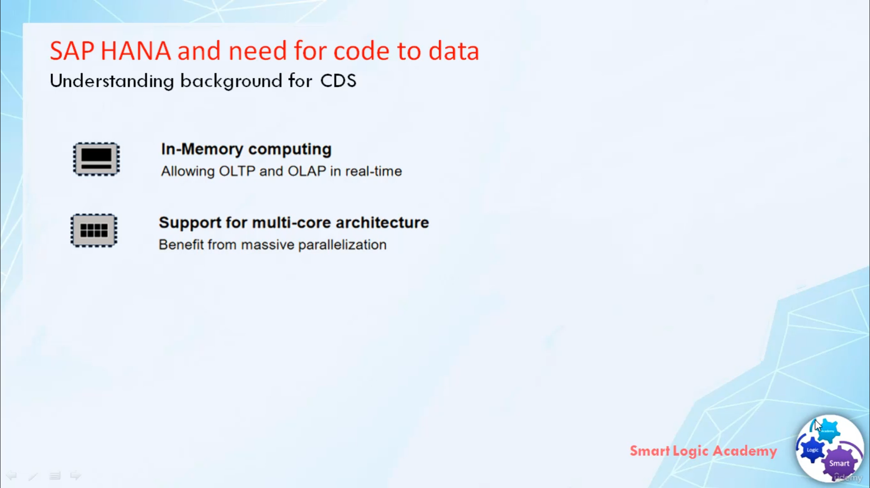

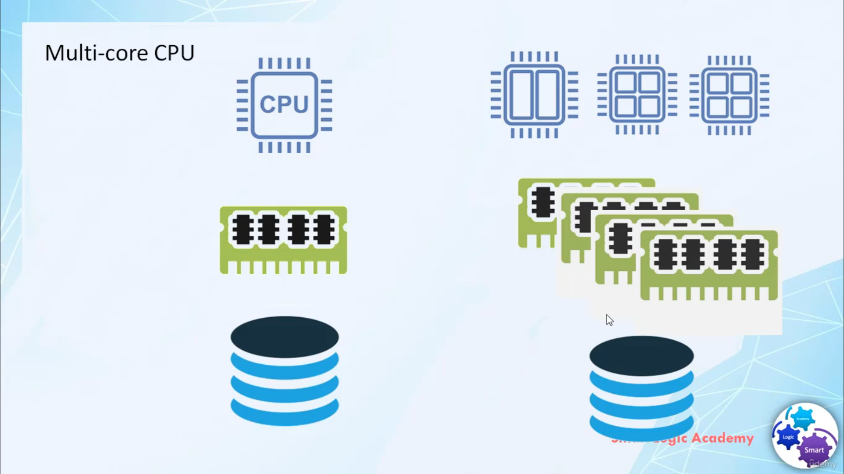

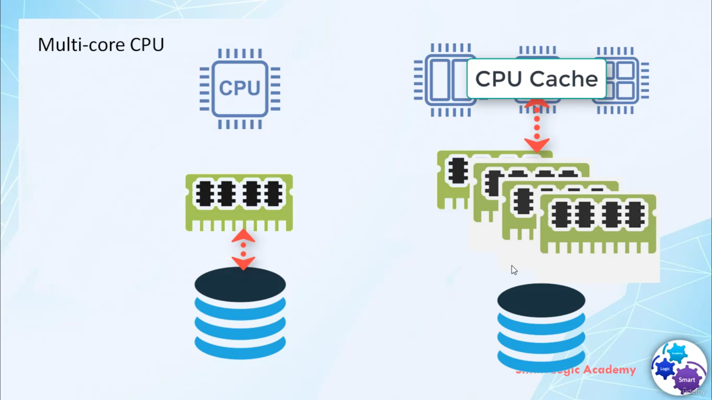

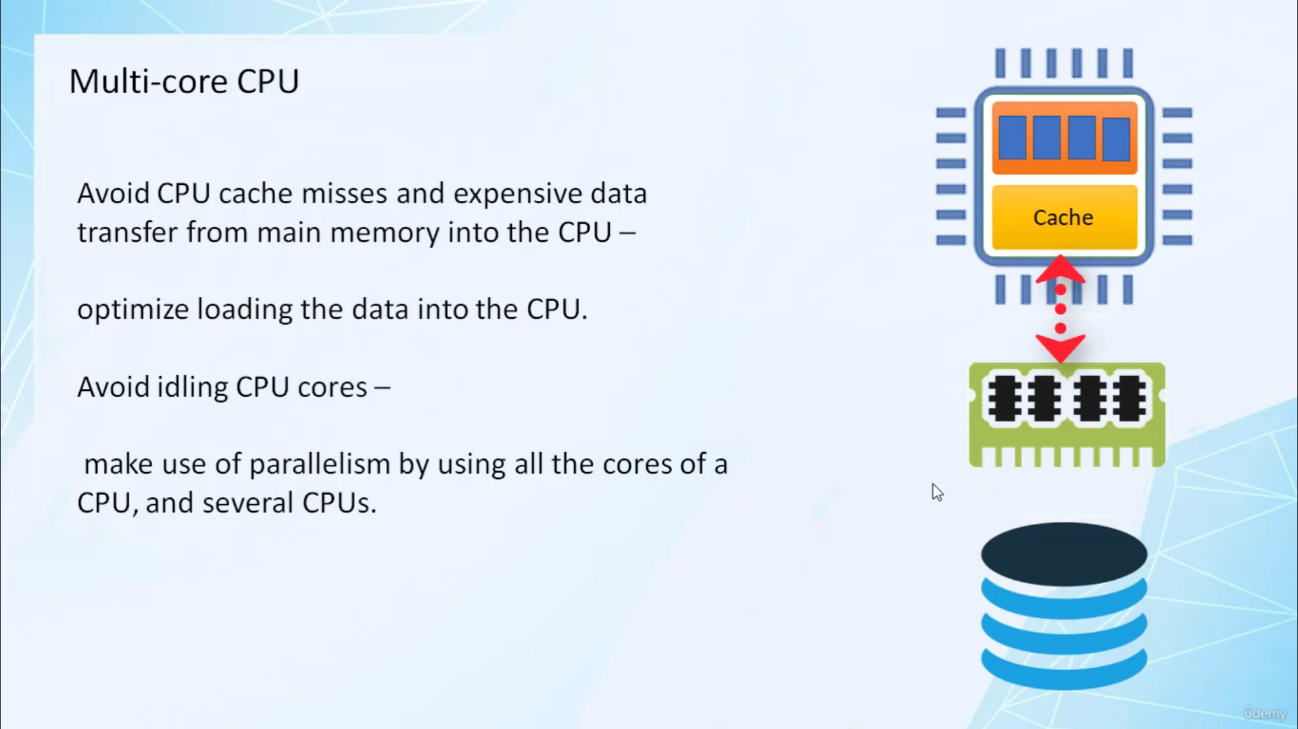

The second important feature in SAP HANA is multi-core architecture. Multi-core architecture helps in parallel processing. Multicore CPU means, CPU can have multiple core, for example, you might have heard of Quad Core, Octa Core and Dual core

In quad-core, we have 4 core and in Octa-Core we have 8 core and in dual-core, we have 2 core. Each core can work independently or in combination with other cores to process data parallelly because of increases in the number of cores.

Now CPUs are able to process increased data per time interval. This shift the performance bottleneck from disk input-output to the data transfer between CPU cache and main memory. To get best performance from current hardware the new bottleneck have to be avoided. In the first challenge, we have to avoid CPU cache misses and expensive data transfer from main memory to the CPU. we can avoid this by optimizing the loading of data into CPU. The second challenge is, we have to avoid idling CPU Cores. We can do this by making use of parallelism by using all the cores of CPU and several CPUs.